2.10 Resting membrane potential

* **Membrane potential**: Electrical gradient inside vs outside across cell membrane, measured in millivolt (mV), negative potential means interior is more negative
  + Change in membrane potential requires the movement of ions across membrane, which generates an electrical current and vis versa, follows $V=IR$
* **Resting membrane potential**: constant membrane potential when the cells are not producing electrical signals
  + Primarily responsible ions: Na+, K+, anions (A−; large, negatively charged intercellular proteins)
  + Other important ions: Cl−, Ca2+
  + Table

    Description automatically generatedNa+, Cl−, Ca2+ in greater concentration out, K+ greater in, A‑ only in (impermeable)
    - **Sodium potassium pump**: 3 Na+ out,   
      2 K+ in, requires ATP
    - A− produced and stay inside
    - Membrane much more permeable to K+ than others
* **Equilibrium potential**: the membrane potential for a specific ion concentration such that the chemical and concentration gradient for that ion balances out (no net movement)
  + Text

    Description automatically generated−90 mV for K+, +60 mV for Na+, −70 mV for Cl−, +120 mV for Ca2+
  + Resting membrane potential is **−70 mV** controlled by percentage permeability of K+ & Na+, tend more towards K+’s equilibrium since it is more permeable
    - Not all ions matter! Only permeability of ions with set concentrations (controlled by the pumps) matter, other ions alter concentrations instead
    - Text

      Description automatically generatedEx: most cells don’t active transport Cl− but is highly permeable, the membrane potential determines its concentration / distribution, which is why it also has −70 mV equilibrium
* **Excitable tissues** (nerve and muscle): can rapidly change membrane potential (by altering membrane permeability to certain ions) to produce electrical signals
  + Diagram

    Description automatically generated with medium confidence**Polarization**: membrane has potential (not 0 mV); at resting potential membrane is polarized at −70 mV in a typical neuron
  + Generally, permeability is altered through (1) changes in electrical field (2) chemical messengers (3) stimulus (sound) (4) spontaneous change in potential
  + **Leak** (open all the time) vs **Gated** (open or closed) channels, gated can be **voltage**, **chemically**, **mechanically**, or **thermally** gated
* There are two basic forms of electrical signals: (1) **graded potentials**, which serve as short-distance signals; and (2) **action potentials**, which signal over long distances.

2.11 Graded potentials

* Slight change in membrane potential, often caused by opening Na channels
* Causes current and spreads to nearby areas **passively**, potential decreases with distance; signal can only travel **short distances**
* **No refractory period**, can lead to action potentials (which have refractory period)
* Ex: postsynaptic potentials, receptor potentials, end-plate potentials, pacemaker potentials, slow-wave potentials

2.12 Action potentials

* Brief, rapid, large changes in membrane potential
* Controlled by voltage-gated Na ad K channels
* Graphical user interface

  Description automatically generated with low confidenceDiagram

  Description automatically generated**Threshold potential**: all-of-none trigger, at threshold
  + (1) **rapid opening of Na activation gates**, Na enter => depolarization
    - Positive feedback loop
  + (2) **slow closing of Na inactivation gates**, halts Na entry after delay
    - Unlike variable duration of graded potential, the duration of an action potential is always the same in a give cell
  + (3) **slow opening of K gates**, K exits => repolarization and hyperpolarization
    - As potential returns, changing voltage shifts the Na channels to closed-but-capable-of-opening, ready to respond to another triggering event
    - K channels also close and the membrane channels returns to resting state
* **Restoration**
  + Long-term: Na-K pumps maintain the concentration gradients
  + Short-term: only about 1 out of 100 000 K & Na ions move, no need to restore
* 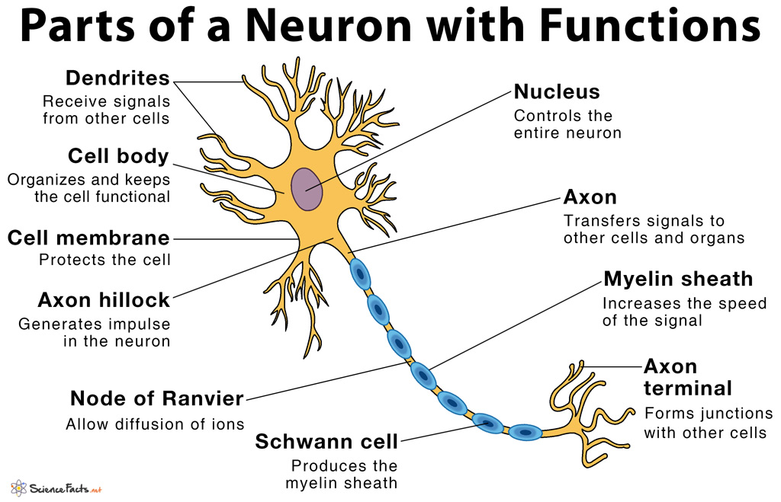**Neuron**
  + **Input zone**: dendrite and cell body; **trigger zone**: **axon hillock**, only place action potential can initiate; **conducting zone**: axon; **output zone**: axon terminal
  + Typically, regions of excitable cells where graded potentials take place do not undergo action potentials (sparse Na channels). However, graded potentials can, before dying out, trigger action potentials in adjacent portions of the membrane
  + Ex: graded potentials are generated in the dendrites and cell body in response to incoming chemical signals, (sufficient magnitude when they spread to the axon hillock) they initiate an action potential at triggering zone, and is conducted along the axon and passed on to another cell at the axon terminal
* **Propagation** (within one cell, between cells is synapse)
  + Within one cell – conducting zone, current spread passively to reach threshold of nearby areas, which then triggers Na channels
    - **Contiguous** (not myelinated) or **saltatory** (myelinated, channels concentrate at node of Ranvier, current “jumps”) conduction
    - one way only, **refractory period**: absolute (Na channels inactivated) vs relative (right after, Na channels capable but threshold hard to reach)
    - diameter & myelination effects speed
* Threshold is all-or-none, signal **strength determined by frequency** instead

2.14 Synapses and neuronal integration

* Diagram

  Description automatically generated**Synapses**: connection between two neurons, specifically between the axon of the presynaptic neuron and the dendrite / cell body of the postsynaptic neuron
  + **Synaptic cleft**: gap between the neurons, only 0.02 um but do not touch
  + **Synaptic knob**: contains synaptic vesicles
    - **Synaptic vesicles**: release neurotransmitters
    - **Calcium channels** open when the action potential arrives, let calcium ions into the cell (causes the release of synaptic vesicles)
  + **Neurotransmitters**: binding to receptor proteins on postsynaptic neuron that trigger ion channels and changes permeability (chemically gated!)
    - **Excitatory**: trigger Na and K channels, slightly depolarize the postsynaptic neuron so its closer to threshold (rarely directly triggers AP)
    - **Inhibitory**: trigger Cl or K channels, slight hyperpolarize the postsynaptic neuron so its further away from threshold
    - Can be both excitatory and inhibitory based on the receptor proteins
  + **Neuropeptides**: large molecules released in a similar way to neurotransmitters
    - **Neuromodulators**: doesn’t cause potential change but acts on the synapse (Ex. changes sensitivity to certain neurotransmitter)
  + After the transmission neurotransmitter are either diffused away, inactivated by enzymes, or reabsorbed by the presynaptic neuron
* **Grand postsynaptic potential** (GPSP): EPSP (excitatory postsynaptic potential) and IPSP (inhibitory postsynaptic potential) are additive, leading to GPSP and potentially AP
  + **Temporal summation**: same place one after another (overlaps slightly each time)
  + **Spatial summation**: different places simultaneously
  + Up to 50 different summations can be required to trigger an action potential
* Presynaptic facilitation / inhabitation: changes behaviour of presynaptic neuron (Ex. make less Ca enter)

3.1 Organization of the Nervous System

* **Peripheral nervous system**: carry information to and from the CNS, 31 pairs of spinal nerves, 12 pairs of cranial nerves
  + **Afferent** (sensory) division carries information to the CNS
  + **Efferent** (motor) division carries information from the CNS to **effector organs**
    - **Somatic nervous system**: voluntary (skeletal muscles)
    - **Autonomic nervous system**: involuntary, controls homeostasis (smooth muscle, cardiac muscle, and glands)
      * **Sympathetic nervous system**: fight or flight response, increases heart & breathing rate, decreases intestinal activity & urination
      * **Parasympathetic nervous system**: opposite of sympathetic
* **Central nervous system**: process information
  + **Brain**: maintain homeostasis; has over 100 billion neurons
  + **Spinal cord**: link between brain and PNS; reflex center
* Diagram

  Description automatically generatedDiagram, timeline

  Description automatically generatedThree types of neurons: **afferent neurons**, **efferent neurons**, and **interneurons** (99% of our neurons are interneurons within the CNS)

3.2 Central Nervous System

* **Brain stem**: oldest in evolution, vegetative functions (unconscious, essential for life)
* **Cerebellum**: coordination and balance
* **Forebrain**
  + **Diencephalon**
    - **Hypothalamus**: homeostasis
    - **Thalamus**: sensation
  + **Cerebrum**: more convoluted in advanced vertebrates, 80% brain weight
    - Diagram

      Description automatically generated**Basal ganglia**: motor control, coordination
    - **Cerebral cortex**: most complex part, many functions including thinking

3.3 Protection for CNS

* **Glial cells** (neuroglia): ~90% of the cells within the CNS, supports the neurons
  + **Astrocytes**: most abundant, many functions
    - Physical support
    - Scaffold during fetal brain development
    - Induce formation of blood–brain barrier
    - Form neural scar tissue
    - Take up and degrade released neurotransmitters
    - Take up excess K to help maintain proper ion concentration
    - Enhance synapse formation and strengthen synaptic transmission
  + **Oligodendrocytes**: Form myelin sheaths in CNS
  + **Microglia**: Defence for brain (phagocytic scavengers)
  + **Ependymal**: Line internal cavities; form cerebrospinal fluid; neural stem cell
* Four protection mechanisms
  + **Bony enclosure**: skull and vertebral column
  + **Meninges**: 3 protective & nourishing membranes
    - **Dura mater**: tough, inelastic; 2 layers, contains dural / venous sinuses (Brian fluids) in between to be returned to the blood stream
    - **Arachnoid mater**: cobweb appearance; protrusions of arachnoid tissue (**arachnoid villi**) penetrate into the dural sinuses
    - Diagram

      Description automatically generatedDiagram

      Description automatically generated**Pia mater**: innermost, fragile, can go deep into the brain to provide blood
  + **Cerebrospinal fluid** (CSF): between arachnoid and pia (subarachnoid space)
    - Same density as brain, shock absorbing
    - Affects composition of **brain interstitial fluid** (direct contact neurons)
    - Formed in **choroid plexuses** (masses of pia mater tissue that dip into pockets formed by ependymal cells), after formation, CSP
      * Flows through the four interconnected ventricles
      * Enters the subarachnoid space from the fourth ventricle
      * Flows between the meningeal layers over the entire surface of CNS
      * At upper regions of the brain, reabsorbed from the subarachnoid space into the venous blood through the arachnoid villi
  + **Blood–brain barrier** (BBB): special capillary structures limit exchange between the blood and brain interstitial fluid
    - **Anatomic**: In brain capillaries cells are joined by tight junctions so nothing can be exchanged by passing between the cells
    - **Physiological**: since exchange can only happen through the cells, ions / big molecules cannot go through without carrier channels

3.4 Spinal Cord

* Spinal cord structure: spinal nerve protected by vertebral column
  + 8 pairs of **cervical** (neck, namely C1–C8), 12 **thoracic** (chest), 5 **lumbar** (abdominal), 5 **sacral** (pelvic), and 1 **coccygeal** (tailbone) nerve
  + Spinal cord extends only to first / second lumbar, remaining nerves (thick bundle of elongated nerve roots) are called the **cauda equina** (horse’s tail)
  + **Grey matter**: primarily cell bodies & dendrites, short interneurons, and glial cells
    - Dorsal (posterior) horn: cell bodies of interneurons
    - Ventral (anterior) horn: cell bodies of efferent (motor) neurons
    - Lateral horn: nerves supply cardiac, smooth muscle and exocrine glands
  + **White matter**: long interneurons axons organized tracts of similar functions, myelinated (grey is unmyelinated)
    - Nerves**:** bundles of axons
    - Tracts**:** bundles of neurons
    - **Ascending tract**: up, carry info to brain, terminates at cerebellum
    - **Descending tract:** down, carry info down to skeletal muscles
  + Diagram

    Description automatically generatedDorsal root (afferent) & ventral root (efferent) & **dorsal root ganglion** (collection of neuronal cell bodies located outside the CNS)
* **Reflex**: activity between afferent input and efferent output without involving the brain
  + **Simple** **reflexes** (basic, instinct) vs **acquired reflexes** (conditioned, learned)
  + **Reflex arc**:
    - **Receptor**: responds to a **stimulus**
    - Afferent pathway: relayed to integrating centre
    - **Integrating centre**: CNS, spinal cord and brain stem integrate basic reflexes, higher brain levels process acquired reflexes
    - **Efferent pathway**: transmit instructions to effector
    - **Effector**: carry out responses
  + Types of reflexes:
    - **Stretch reflex**: **monosynaptic**, stretch-detecting receptor directly connector to effector to counter the stretch (contract the same muscle)
      * Knee jerk, essential for standing straight under gravity
    - **Withdrawal reflex**: polysynaptic, spinal reflex (all transmissions done in spinal cord), can be overridden voluntarily, 3 parts (Ex. Hand on fire)
      * Contract muscle to withdraw hand
      * **Reciprocal innervation**: relaxes opposite muscle
      * Notify the brain
    - Golgi tendon reflex: prevents over-contraction, kind of opposite to stretch but polysynaptic
    - Crossed extensor reflex: controls opposite side of body couple with withdraw reflex for posture / balance

3.5 Brain Stem

* 3 regions: **Midbrain**, **pons**, and **medulla**
* 5 functions:
  + Majority of the 12 pairs of **cranial nerves** arise from the brain stem except vagus (major nerve of the parasympathetic nervous system)
  + **Neuronal clusters** (centres) control heart, blood vessel, respiration, and digestion
  + Muscle reflexes involved in **equilibrium and posture**
  + **Reticular formation** (widespread network of interconnected neurons): ascending fibres (**reticular activating system** (RAS)) carry signals upward to arouse and activate the cerebral cortex and controls **alertness / attention**
  + Diagram

    Description automatically generated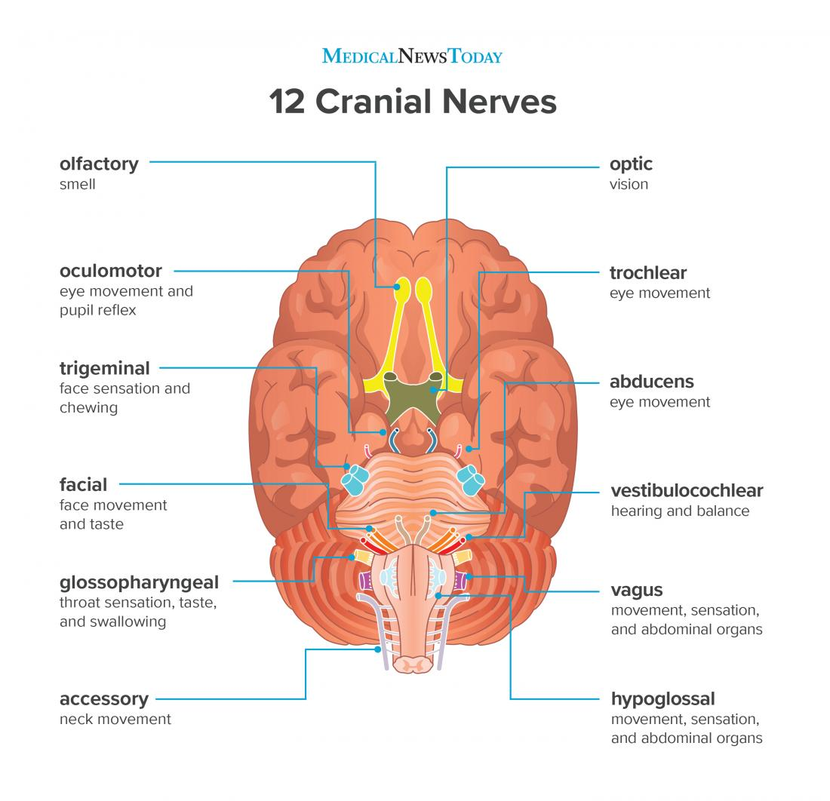**Sleep** traditionally have been considered to be controlled by brain stem, although recent evidence suggests that slow wave sleep is controlled by hypothalamus

3.7 Cerebral Cortex

* Right and left cerebral hemispheres connected by **corpus callosum** (thick band consisting of ~300 million neuronal axons travelling between the two hemispheres)
* Diagram

  Description automatically generatedBrain **plasticity**